PROJECT RIG #UNRIG: improve #UNRIG’s Earth Intelligence Network EIN with the firefly - heartbeat algorithm emulating Artificial Intelligence A.I. neural net activity

* **Enhance EIN with NATO situational awareness swords to plowshare best practice**
* **Enhance EIN with NATO best practice of individuals joining (federated) groups**
* **Improve EIN with concepts and best practice derived from mankind’s “giants”**

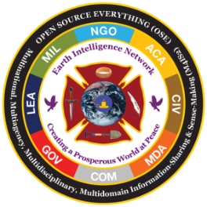[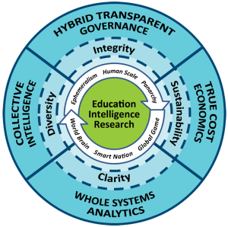](https://i2.wp.com/www.phibetaiota.net/wp-content/uploads/2014/02/EIN-Logo-METHOD-best.png)

Phi Beta Iota LOGO - SEE: LINK <https://phibetaiota.net/unrig/> Phi Beta Iota's logo consists of the Whole Earth within a Rescue Cross, with four symbols: the bowl for food and water; the quill pen for education, communication; the shovel for construction, development; and the stiletto for the inevitable rogues that need “a time-out”. On a white field we show our public purpose: creating a prosperous world at peace. It original and long-term focus is on teaching citizens the urgency of demanding holistic analytics, true cost economics, and Open Source Everything Engineering (OSEE) as the foundation for enlightened self - governance.

PROJECT: RIG #UNRIG’s Earth Intelligence Network by supporting it, improving it, enhancing Phi Beta Iota's EIN Earth Intelligence Network with improved DARPA / NATO derived system of systems signaling, telemetry engineering research and NATO best practice a.k.a. The Heart Beacon Cycle Time – Space Meter and Applique Overlay (dashboard). SOURCE [LINK](https://www.scribd.com/doc/181753327/Heart-Beacon-Cycle-Time-Space-Meter) SCRIBD DOT COM slideshow

Update Global dashboards using an algorithm that emulates neural network activity namely, the firefly inspired heartbeat algorithm attributed to the Universities of Bologna Italy and Hungary - improved by matching the firefly synchronization activity to the nearest heartbeat OPTEMPO cycle -- attributed to patent application 13/573,002 Heart Beacon Cycle Time – Space Meter <http://sawconcepts.com/index>

PROJECT: rig #UNRIG Earth Intelligence Network with a neural network emulation algorithm - the firefly inspired heartbeat synchronization algorithm co-designed by the University of Bologna, Italy / Hungary Source

[#UNRIG](https://steemit.com/trending/unrig) seeks to communicate to all citizens the possibility of an ethical, legal, non-violent restoration of integrity to the US Government. Background information

Phi Beta Iota "We do this, in an expansion of Buckminster Fuller’s practice, by enabling hybrid governance through ethical evidence-based decision-support in the context of transparent, truthful networks of trust. The outermost border summarizes our two innovative methods for which we are the foremost proponents in the world: Open Source Everything (the only technical solution that is affordable, inter-operable, and scalable) and Multinational, Multiagency, Multidisciplinary, Multi-domain Information-Sharing and Sense-Making (M4IS2, the only human solution that assures holistic analytics and a grasp of true cost economics)".

A picture containing text

Description generated with high confidence 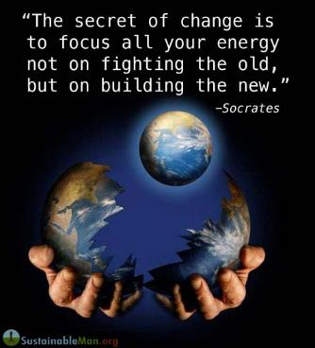

Phi Beta Iota "Our mind-set is deeply rooted in Ecological Economics as pioneered by Dr. Herman Daly and subsequently described in books by the titles of Ecology of Commerce and Natural Capitalism. We believe that the Earth is amply sufficient to provide every human now living with a life that is both prosperous and secure — where we have gone wrong is in allowing a select few to internalize profit and externalize cost" - attributed to Phi Beta Iota



Quote attributed to Phi Beta Iota "Government — in isolation from the other seven tribes shown in the EIN logo — has failed. We must move to hybrid transparent governance, leveraging a combination of collective intelligence and true cost economics, to achieve whole systems understanding through holistic analytics"

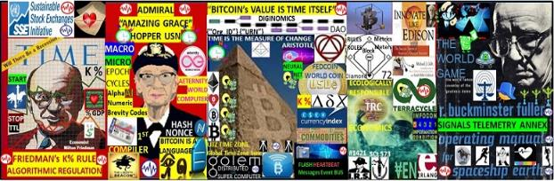

THEME: STANDING ON THE SHOULDERS OF GIANTS Economist Milton Friedman, Admiral Grace Hopper, Inventor Thomas Edison, Economist Bernard Lietaer, sustainable giant Buckminster Fuller, Doctor Martin Luther King Junior, are a few of the giants / luminaries that the author attributes useful additions forming an adaptive procedural template checklist of useful ideas, processes, procedures, concepts... etc., that a trade federation would use to accomplish it’s goals.

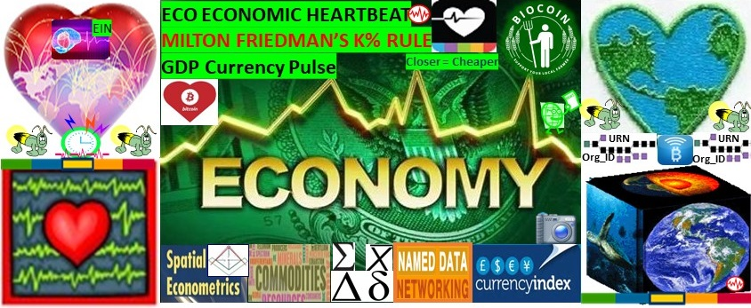

USPTO application 13/573,002 Heart Beacon Cycle Time - Space Meter / Main Use cases: - Ecologically sustainable economic heartbeat

- Programmable economy syntax lexicon Namespace

We propose novel use of a heartbeat synchronization algorithm based on nature (fireflies) to establish consistent, equitable metrics, to compensate tokenized commodities demurrage parking fees. We propose ecologically responsible trade incentives i.e., closer = cheaper, less fuel.

IF [#ClimateChange](https://www.facebook.com/hashtag/climatechange?source=feed_text&epa=HASHTAG) causes a drop in [#crop](https://www.facebook.com/hashtag/crop?source=feed_text&epa=HASHTAG) [#commodity](https://www.facebook.com/hashtag/commodity?source=feed_text&epa=HASHTAG) food production by 20–25 % while [#population](https://www.facebook.com/hashtag/population?source=feed_text&epa=HASHTAG) continues to grow, THEN it follows that this condition will become a [#NationalSecurity](https://www.facebook.com/hashtag/nationalsecurity?source=feed_text&epa=HASHTAG) matter. It’s TIME to implement an Eco sustainable Economic Heartbeat ELSE face greater chaos then would otherwise be necessary.

Is it TIME to rig #UNRIG’s EIN Earth Intelligence Network with a neural net yet?

A screenshot of a cell phone

Description generated with very high confidence

FIGURE 1: OPERATION RIG [#UNRIG](https://steemit.com/trending/unrig) Earth Intelligence Network with a Heart Beacon Signals, Telemetry Sync, Syntax Lexicon Library neural network emulation SOURCE [LINK](http://sawconcepts.com/index/id84.html) <http://www.sawconcepts.com/index/id84.html>

The Earth Intelligence Network will be a composite, system of systems comprised of many nations Telco mesh fabrics. Eventually, it will be formed from all nation states as a system of systems situational understanding type project that will arguably need a universal method and means to receive event and alert messages independent of protocol or programming language within the matrix if you will.

We propose a neural network emulation based on nature - fireflies - using an algorithm conceived by University of Hungary / Bologna Italy. Project Rig [#UNRIG](https://steemit.com/trending/unrig): use an algorithm inspired by fireflies that emulates neural network activity for [#UNRIG](https://steemit.com/trending/unrig)’s Earth Intelligence Network reusing tax payer paid for research and best practice into system of systems engineering Battlefield Digitization / Network Enabled Operations NEO swords to plowshares style

A picture containing text

Description generated with high confidence

FIGURE 2: Project rig #UNRIG's Earth Intelligence Network EIN with a system of systems Signals & Telemetry mesh derived from NATO's Battlefield Digitization, Net Enabled Operations NEO [LINK](http://sawconcepts.com/index/id90.html) http://sawconcepts.com/index/id90.html

This project can support with shared common Signals and Telemetry through OOTW reuse of Battlefield Digitization / Network Enabled Operations NEO, the Earth Intelligence Network and proposes a neural network emulation using the firefly-heartbeat synchronization algorithm conceived by U Hungary / Bologna Italy.

Dogezer is a software development platform that allows team members to become product investors by investing their time and labor. Dogezer Solution Explained The Dogezer Platform is a SaaS solution which combines the functionality of Kickstarter, UpWork, GitHub, Slack, Jira, Google Docs, Dropbox and ICO analogues with a set of defined processes how these solutions relate to each other in a clear, transparent and predictable way. Dogezer will give an opportunity to start a project in a matter of minutes; organize a set of teams who will be working on the project; define how project contributions will be rewarded, and then drive the project to completion by utilizing skills of independent contributors all around the world. Dogezer will implement most of the key tools used in software development as integrated pieces. Over time, the variety of services offered by Dogezer will grow, eventually resulting in a complete set of tools that are required to run a top-notch software development company. As a result, the Dogezer solution will become a single service, one-stop-shop that companies that operate in a traditional environment can replace their current fragmented landscape toolset. [LINK](https://dogezer.com/) https://dogezer.com/

The Heart Beacon Cycle is a procedural template framework that includes citations of required standards, processes, components / building blocks and conventions that are agreed upon as criteria required as a minimum to join trade federations.

A screenshot of a newspaper

Description generated with very high confidence

FIGURE 3: The Heart Beacon Cycle HBC is an adaptive procedural template checklist of things, processes, tools, building blocks useful to form, maintain Eco-responsible trade federations. Source link: http://sawconcepts.com/index/id3.html

The Heart Beacon Cycle is a checklist., an adaptive, procedural template checklist for forming trade federations supporting ecologically friendly business transactions and Eco-friendly geo-spatial econometrics where closer is cheaper, closer is faster and most importantly, uses less environmentally polluting fuel. This strategy will significantly reduce the CO2 carbon footprint. Each item in the procedural template checklist links to a detailed treatise. We can synchronize ourselves and our cities in time - space for a common purpose: ecologically sound econometrics.

* A process defines “what” needs to be done and which roles are involved.
* A procedure defines “how” to do the task. Example: roles and responsibilities of the people (roles) assigned to do the work, tools and equipment to support individuals do their jobs, and procedures and methods defining how to do the tasks and relationships, work flows connecting steps between the tasks.

A screenshot of a cell phone

Description generated with very high confidence

FIGURE 4: German Military H.A.N.D.S. O.O.T.W PROPOSAL H.A.N.D.S

The model template framework is the United States Army / Marine Corps Joint Battle Command JBC also known as Joint Blue Force Situation Awareness and it’s associated Army Battle Command System ABCS referred to as Future Combat Systems FCS. The template system is part of a system of systems. It’s interaction with many other intelligence, logistics, maneuver etc. systems participating in a system of systems. To achieve consensus, selecting the most widely implemented Situation Awareness System -- Joint Blue Force Situation Awareness or JBFSA US Army Communication Electronic Command CECOM's greatest invention – Blue Force Tracker. co-developed Marine Corps is the path of least resistance.

The military has always done one thing very well — form individuals into groups working synchronized in time – space (use of geo-spatial map overlays) towards accomplishing a myriad of missions such as transacting in food, water, fuel services in host nation agreements already established in most countries. and reused in German military OOTW Operations Other than War. Deriving common building blocks from JBFSA common to stock exchange, First Response Systems (heartbeat / heartbeat messages) is key [LINK](http://sawconcepts.com/index/id20.html) <http://sawconcepts.com/index/id20.html>

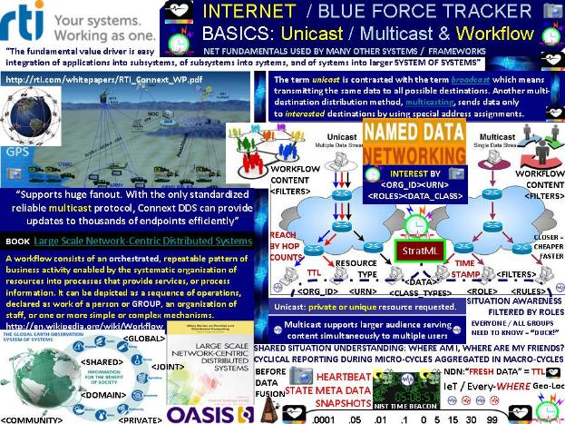

FIGURE 5: TEMPLATE SYSTEM OF SYSTEMS BLUE FORCE TRACKING / ABCS

Battlefield Digitization was created by the United State's taxpayers dollars and is a key citation that I give credit to the Army and the Marine Corps... all building blocks, processes, people's work the author deems useful for inclusion into an adaptive procedural template checklist useful to form and maintain trade federations.

The US Army / NATO uses networks and router / router subnets to emulate orders and schemes of maneuver. To determine if a squad or platoon is mission capable or where it is supposed to be and equipped with the requisite resources: food, water, fuel, ammo etc,’ data is sampled and forwarded using a minimum of network resources -- in other words TIME. The Internet Protocol was examined closely and it was re-discovered that time interval frame assignments were unassigned / available to transport additional state meta data. Heretofore unassigned time intervals set aside for future use were used to carry data about the organization -- it's unit designation or Organizational Identifier Org_ID, it's geo-location and resources URN Uniform Resource Name. SOURCE [LINK](http://www.sawconcepts.com/index/id37.html) <http://sawconcepts.com/index/id37.html>

A screenshot of a cell phone

Description generated with high confidence

FIGURE 6: Federate, Federations / Distributed Autonomous Organizations DAO

FEDERATION: from Latin: foedus, gen.: foederis, covenant characterized by a union of partially self-governing states or regions under a central (federal) government. In a federation, the self-governing status of the component states, as well as the division of power between them and the central government, are typically constitutionally entrenched and may not be altered by a unilateral decision of either party, the states or the federal political body.  Individuals, organizations retain AUTONOMY to act on their own behalf. Reuse of military funded System of Systems research, best practice re-used as a procedural template framework is key to forming and maintaining sustainable Trade Federations as Distributed Autonomous Organizations DAO's / DAC's Corporations.

**The Official Start of the Token Sale of the First «Kosher» (Jewish) Crypto-Token and Blockchain Ecosystem BitCoen.io**

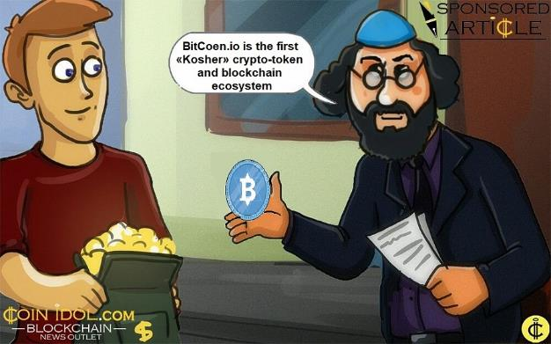

CoinIdol Article: “The blockchain project BitCoen was originally conceived as a system of services, qualitatively improving the life of the Jewish community," explains Vyacheslav Semenchuk. "This is a fairly closed community, existing Worldwide. This community has needs in internal mutual settlements, to help their own businesses, oriented only for Jews; and has a big culture of charity. And all these needs must be accomplished in the most transparent and profitable way. The ideal target audience for a blockchain project! So we came up with the BitCoen ecosystem idea, which integrated the useful mechanics from the world of the blockchain. The team members work all over the world. “The development of Internet technologies allowed us to create an international team,” says Vyacheslav Semenchuk. “The BitCoen team includes the most experienced blockchain programmers, crypto marketers and other experts in crypto-economics, who got interested in creating an ambitious, high-quality and interesting project." [LINK](https://coinidol.com/official-start-of-token-sale-of-first-kosher-crypto-token-and-blockchain-ecosystem/)

Military's do one thing very well -- organize individuals into organizations <OrgID> and Organizational Units <OU><OU><OU>as widely dispersed autonomous groups working towards collective, synchronized goals following cyclical, iterative procedures. Shown above is a fusion between #Bitcoin / military net centric operations both use term DAO Distributed Autonomous Organization. DAO term first used by RAND military think tank in 2001 - now in use by Bitcoin community

The Heart Beacon Cycle Time - Space Meter main use case: synchronizing geo-spatial temporal Eco - Econometrics among Trade Federations / DAO Distributed Autonomous Organizations. Members of trade federations agree to use standards, processes, shared components / building blocks and conventions.

The trade federation’s adaptive procedural template checklist is agreed upon as items as minimum requirements to join a trade federation (cloud computing term). Entries to the procedural template checklist -- a clipboard of things needed to accomplish a goal (establish a trade federation) refer to detailed treatises.

Project: form trade federations of autonomous communities, states / sovereign nations following a procedural template checklist promoting synchronization among geo-spatially dispersed groups. Federated groups follow a procedural template guiding group activities across time - space to achieve synergy, synchronicity and inter community cooperation where activities are orchestrated from grassroots to capitals, from micro to macro-economic cycles. SOURCE [URL](http://sawconcepts.com/index/id5.html) <http://sawconcepts.com/index/id5.html>

A sign on a pole on a city street

Description generated with very high confidenceA person holding a sign

Description generated with very high confidence

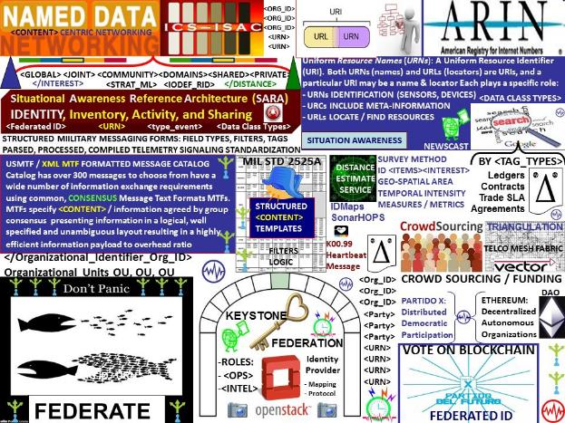

FIGURE 7: FEDERATE AND GRADUATE / FEDERATION SYNTAX LEXICON

Project: form trade federations of autonomous communities, states / sovereign nations following a procedural template checklist promoting synchronization among geo-spatially dispersed groups. Federated groups follow a procedural template guiding group activities across time - space to achieve synergy, synchronicity and inter community cooperation where activities are orchestrated from grassroots to capitals, from micro to macro economic cycles. Distributed Autonomous Organization / Corporations DAO - DAC federated trade organizations. Synchronous, reliable, predicable cyclical update of state meta data snapshots across a system of systems is flexible, and adaptable across many use cases. The System of systems engineer approach improves systemic, sustainable solutions through cyclic, reliable, predicable signaling, telemetry, news-casting of sync delta updates across a network of networks defining equitable metrics, meters for trade arbitrage among federated, autonomous trade groups SOURCE [LINK](http://www.sawconcepts.com/index/id6.html)

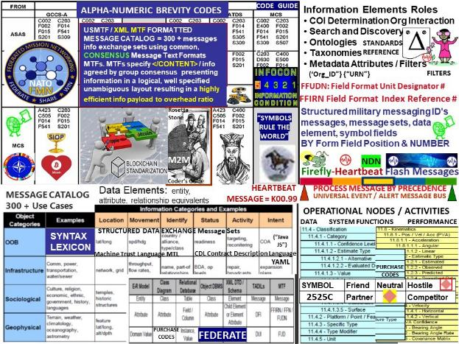

FIGURE 8 Syntax Lexicon Library 300 + Message Template NATO Use Cases

Syntax is represented by template spreadsheet form fields ''FFIRN's", "FFUDNS" in structured military messaging where the form number and field position has significance and reduces data type ambiguity in message set parsing, processing.

Our proposal is to reuse the logic behind structured military messaging form field unit identifiers in commercial use cases. A method to convert syntax conventions among the myriad metaphors and memes -- a Rosetta Stone syntax lexicon library is needed. LINK http://sawconcepts.com/index/id4.html

The HBC involves a heartbeat flash message universal event, alert message bus. It is based on NATO's best practice, 300 + structured data exchange templates, micro-macro (economic) situational awareness sync delta data exchange schedule. The Heart Beacon cycle includes a universal metrics measurements physical meme (see Supreme Court Alice Corp Vs CLS Bank) for use among myriad Bitcoin Blockchain internet of money Block-Time arbitrage memes to support standardization of a one world economic system of systems.

Cyclic updates of state meta data snapshots / heartbeat messages from micro-to macro (economic) cycles distributed among a system of systems is simply powerful and is key to forming the net Grail. The military adopted the policy of only sending changes or "heartbeat sync deltas" for the same reason the Bitcoin community must adopt the same paradigm. SOURCE [LINK](http://www.sawconcepts.com/index/id44.html)

A screenshot of a cell phone

Description generated with high confidence

FIGURE 9: NATO STRUCTURED DATA EXCHAGE MESSAGE TEMPLATES

NATO’s best practice, 300 + structured data exchange templates, micro-macro situational awareness sync delta data exchange schedule. Sending changes, not the entire document or the "sync delta's" in military parlance conserves bandwidth and increases throughput. The military relies on "heartbeat" messages as do stock exchanges -- I.e., FIX ("108") heartbeat messages, First response, time sync systems etc, etc. The Internet is based on time cycles and(computer) syntax parsed / processed or not during finite time cycles. It requires a syntax library lexicon -- a Rosetta Stone. NATO's [#interoperability](https://twitter.com/hashtag/interoperability?src=hash) system of systems framework i.e., sync delta's, structured data exchange alpha numeric brevity codes, symbol sets... is the best starting point - in my opinion. [#Coindesk](https://twitter.com/hashtag/Coindesk?src=hash): The Opportunity for Interoperable Chains of Chains [LINK](http://www.sawconcepts.com/index/id52.html)

A screenshot of a cell phone

Description generated with high confidence

FIGURE 10: Firefly - Heart Beacon Algorithm by University Bologna / Hungary

“The shortest path to the knowledge of truth is through nature” Luxor Temple Inscription: [LINK](http://sawconcepts.com/index/id22.html) <http://sawconcepts.com/index/id22.html>

FIREFLY INSPIRED HEARTBEAT SYNCHRONIZATION:

1) Consensus 2) Neural Network emulation

3) Event Bus for Bitcoin transactions as taxable events

4) Stochastic Harmonization 4) stock exchange events for MMID Dark pool limits

The Earth Intelligence Network will benefit from a universal algorithm that includes flash heartbeat messages reporting changes to the system of systems such as events / alerts. We propose an algorithm based on nature to form a neural network emulation conceived by the University of Hungary and Bologna Italy whose alumni includes the Borgia Pope. University of Bologna Alumni [citation](http://www.newadvent.org/cathen/01289a.htm)

A picture containing text

Description generated with high confidence

**FIG 11: TERRA Trade Reference Currency / Crypto Micropayments – Demurrage fees**

Satoshi Nakamoto: "#Bitcoin is intended to be paired with the market place" "the blockchain stores references to market indexes"

**Demurrage: term used in currency trading to denote cost of currency ownership and/or storage. cost of carrying money… considered superior to interest payments, as it stimulates currency circulation and economic growth. “In a physical sense, demurrage represents a delay that occurs during the transportation of goods via truck. When this happens, the trucking firm delivering the product can opt to pay a flat fee to the receiver to cover any loss incurred as a result of the delay. This fee can be assessed on an hourly basis. Or in the case of gold, demurrage is simply the costs associated with storage of bouillon.** [**LINK**](https://investopedia.com/terms/d/demurrage.asp)[**https://investopedia.com/terms/d/demurrage.asp**](https://investopedia.com/terms/d/demurrage.asp)

Thomas Edison’s Monetary Option: [LINK](https://www.supermoney.com/2014/06/thomas-edisons-view-money/): <https://www.supermoney.com/2014/06/thomas-edisons-view-money/>

[LINK](http://sawconcepts.com/index/id6.html) <http://sawconcepts.com/index/id39.html>

A screenshot of a cell phone

Description generated with very high confidence

**FIGURE 12: ECONOMIST MILTON FRIEDMAN’s K % RULE / Algorithmic Economic Regulation**

**Economist Milton Friedman predicted the rise of a computer capable of automatically adjusting the inflation rate of money, and this is precisely what we see in the case of bitcoin, as a regulatory algorithm intelligently adjusts the mining difficulty to make the issuance of blocks more or less easy depending on the demand for network hashing power. No money system we have seen to date can claim it is chronologically regulated. The universal construct of time is the backbone of the cryptocurrency digital economy. Investopedia K % Rule** [Source](https://www.investopedia.com/terms/k/k-percent-rule.asp)**: https://investopedia.com/terms/k/k-percent-rule.asp**

**Satoshi Nakamoto’s Bitcoin key building block is a time stamp server. Satoshi Nakamoto: "Bitcoin is intended to be paired with the market place" "the blockchain stores references to market indexes" Globalization involves multi-national corporate entities vying for control of regional resources. It follows that a proven strategy to identify, track, and monitor resources regionally within the global economic matrix is needed. Bitcoin cryptocurrencies as programmable money and the internet's heartbeat, heartbeat messages timed to harvest data during micro economic cycles then aggregated into a composite economic heartbeat pulse as Economist Milton Friedman’s K% rule is a clear and present opportunity for trade equity and economic system of systems stability.** <Source:> <http://sawconcepts.com/index/id43.html>

A screenshot of a cell phone

Description generated with very high confidence

**FIGURE 2: FEDCOIN / WORLDCOIN = ECONOMIC HEARTBEAT**

**Economic Reset solution: form economic trade federations incentivizing environment friendly business practices leveraging Bitcoin's micro-payment capabilities supporting the TERRA Trade Reference Currency TRC demurrage resource handling charge. Closer is cheaper, less fuel, less C02 carbon emissions.**

**Main building blocks: WAVES: TOKENIZES NATIONAL CURRENCIES**

**- Firefly Heartbeat algorithm Time – Space Sync algorithm improved by matching firefly async / sync process to closest Operational Tempo OPTEMPO heartbeat time epoch cycle**

**- TERRA TRC TRADE REFERENCE CURRENCY Commodity (crops etc., )**

**- ECONOMIST MILTON FRIEDMAN"S K% RULE Lead Economic Indicator pulse**

**Use Thomas Edison's commodity backed index recommendation 1921, Milton Friedman's K % rule, Economist Bernard Lietaer's TERRA TRC Trade Reference Currency concepts in concert with the firefly-heartbeat algorithm developed by the University of Bologna, University of Hungary = ECONOMIC HEARTBEAT FEDCOIN / WORLDCOIN** SOURCE [LINK](http://www.sawconcepts.com/index/id11.html): <http://sawconcepts.com/index/id9.html>

A screenshot of a cell phone

Description generated with high confidence

FIGURE 14: HFT CIRCUIT BREAKER / Blockchain transaction speed algorithmic regulation [LINK](http://sawconcepts.com/index/id18.html)

**Algorithmic regulation, speed parity between mainframe supercomputers and blockchain trade**

**MFID II DARKPOOL HFT High Frequency Trade Limits: Sustainable Stock Exchange Initiative**

**I.R.S. Internal Revenue Service 2018 Tax Code change: Bitcoin A, B, C to N type exchanges = taxable events**

**Use the "Great John Nash's" Equilibrium algorithms to address trade parity among “whales”**

Firefly inspired heartbeat synchronization algorithm use cases in stock, currency , commodity exchanges: algorithmic regulation. Improving temporal trade parity between Bitcoin Blockchain & conventional stock exchanges by using the firefly-heartbeat algorithm to take trade speed samples among trade populations across time zones to determine an optimal trade speed / frequency as a statistical mean value index pulse. On off trade floor parity = sonar water drop in pond meme radius distance / Dark Pool circuit breaker #UTZ universal time zone stochastic harmonization See USPTO 13/573,002, US Sct #573 Alice Corp Vs CLS Bank "claims may not direct towards abstract ideas" = physical sonar water drop in pond meme for radius distance from stock, commodity exchange trade floors #Bitcoin World Economic Heartbeat http://sawconcepts.com/index/id18.html [LINK](http://sawconcepts.com/index/id18.html)

Use Case: algorithmic regulation. For example, improving temporal trade parity between Bitcoin Blockchain & conventional stock exchanges by using the firefly-heartbeat algorithm to take trade speed samples among trade populations across time zones to determine an optimal trade speed / frequency as a statistical mean.

Trading velocity far exceeds Bitcoin's current transaction rates estimated to be between 3 - 7 transactions per second and far exceed non-HFT trading capacity. A method is needed to establish temporal trade parity and account for on floor / off floor trading disparity -- enter STAAS Space - Time As A Service TAAS using a novel stochastic harmonization algorithm based on the mating behavior of certain species of fireflies that strive to sync during mating activity. The fireflies attempt to arrive at a uniform flash rate (consensus) is matched to the closest heartbeat cycle.

All sophisticated algorithms, bots, mots, scripts, agents make use of the heartbeat -- opportunities, intervals, windows in time. High frequency flash trade algorithms are sophisticated and distributed -- however, all algorithms report to a single master controller. The heartbeat = start bit / stop bit, Time To Live = algorithm on / algorithm off / algorithm duration. Heartbeat </108> messages and the heartbeat time cycle can be used to limit trade sessions by trading session or trade time cycle e.g., one trade per cycle and / or n trades per session.

Math genius John Nash of Princeton’s equilibrium theorem may be used for stock, currency market equilibrium through use of algorithms to control cartel behavior through sanctions and penalties. The increasing reliance on game theory as a foundation for auctions and electronic commerce, efficient algorithms for computing equilibria in multiplayer general-sum games are of practical interest for example, in finding a Nash equilibrium for an average-payoff repeated bi-matrix game polynomial-time algorithm. Finite-state equilibrium strategies can be found efficiently and expressed succinctly. Paper: A Polynomial-time Nash Equilibrium Algorithm for Repeated Games: LINK <http://bit.ly/1NWeLLu>

STORM / TRIDENT applies real time distributed computation of events at speeds of a million tuples per node per second using worker / task heartbeats to get put instructions for example, to Wall Street high frequency flash trade describing trade window Time To Live TTL and start, stop commands e.g., stop commands to runaway stock exchange trading sessions.

**A use case of the firefly inspired heartbeat synchronization algorithm in stock and currency exchanges is algorithmic regulation. For example, improving temporal trade parity between Bitcoin Blockchain & conventional stock exchanges by using the firefly-heartbeat algorithm to take trade speed samples among trade populations across time zones to determine an optimal trade speed / frequency as a statistical mean.  Trading velocity far exceeds Bitcoin's current transaction rates estimated to be between 3 - 7 transactions per second and far exceed non-HFT trading capacity. A method is needed to establish temporal trade parity and on floor / off floor**

A screenshot of a cell phone screen with text

Description generated with very high confidence

FIGURE 15 ENERGY TOKEN ECONOMY METRICS – METERS

Heartbeat Messages used in power, internet systems: shows energy grid protocols that use a heartbeat, heartbeat messages. IEC C37.118 Harmonization and Synchronization is used across smart grid applications and specifies a heartbeat update interval in milliseconds -- depending on the time sync source. Micro-grid use is set to increase dramatically in both military and commercial applications.

The ability to accurately, reliably and consistently meter changes in power consumption between a community specializing in micro-grid energy production and a community specializing in a ecology module purifying water or producing bio-mass can monitor usage in terms of surpluses or shortages based on the last sync delta update across a consortium as a basis for exchange based on group concurrence such as Service Level Agreements SLA performance measures. SOURCE [LINK](LINK:%20http://sawconcepts.com/index/id16.html): <http://sawconcepts.com/index/id16.html>

A screenshot of a cell phone

Description generated with very high confidence

FIGURE 16: IDMaps – SonarHops Distance Estimation Service

GOAL: [#Cloud](https://steemit.com/trending/cloud), [#IoT](https://steemit.com/trending/iot), [#Blockchain](https://steemit.com/trending/blockchain) Service Level Agreements SLA incentivized Eco friendly transactions leveraging bitcoin’s micro payment function supporting the TERRA Trade Reference Currency TRC by economist Lietaer For example, closer = cheaper, closer = less fuel ? Globalization involves multi-national corporate entities vying for control of regional resources. It follows that a proven strategy to identify, track, and monitor resources regionally within the global economic matrix is needed. The Heart Beacon Cycle Time - Space meter describes universal geo-spatial econometrics and meters and includes distance location services such as IDMaps - SonarHops. Geo-spatial temporal techniques like IDMaps /SonarHops and the firefly heartbeat stochastic harmonization method can be used to account for trades distributed across time zones and trading on the stock exchange floor and off where the length of the fiber optic cable is significant in High Frequency Trade volume.

Globalization involves multi-national corporate entities vying for control of regional resources. A proven strategy to identify, track, and monitor resources regionally within the global economic matrix is needed. The Heart Beacon Cycle: a procedural template listing tools, syntax, processes useful in forming, maintaining a system of services providing consistent scheduling of micro-services reporting to macro-cycle updates to decision support overlays and scheduling signaling, telemetry exchanges among a collective, distributed system of (economic) systems. SOURCE [LINK](http://sawconcepts.com/index/id24.html): <http://sawconcepts.com/index/id24.html>

A picture containing text

Description generated with high confidence

FIGURE 17: SIGNALS AND TELEMETRY ANNEX FOR OUR SPACESHIP EARTH

“We can synchronize ourselves and our cities in time - space for a common purpose: Dr. Jose Arguelles of the Law of Time dot org -- ecologically sound econometrics i.e., through use of a Signals and Telemetry annex for Buckminster Fuller’s Operations Manual for Spaceship Earth. The HBC involves a heartbeat flash message universal event, alert message bus. It is based on NATO's best practice, 300 + structured data exchange templates, micro-macro (economic) situational awareness sync delta data micro to macro eco economic exchange schedule.

Ecologically sound econometrics - The Heart Beacon Cycle Time — Space Meter USPTO 13/573,002 is a Signals, Telemetry annex for Buckminster Fuller’s Operations Manual for Spaceship Earth. Our proposal is based on a proven system of systems building blocks and best practice framework leveraging a signaling, telemetry heartbeat flash message universal event, alert message bus.

EVERYDAY SHOULD BE SPACESHIP EARTH DAY see article on Medium dot com SOURCE [LINK](http://bit.ly/2onq90G) <http://bit.ly/2onq90G> SOURCE [LINK](http://sawconcepts.com/index/id56.html): <http://sawconcepts.com/index/id56.html>

A close up of text on a black background

Description generated with high confidenceA close up of text on a white background

Description generated with high confidence

RBF "the secret to change is build a new model that makes the old model obsolete" RBF "Earth is a spaceship that cannot be resupplied". WHAT IF EVERYDAY IS SPACESHIP EARTH DAY ? What if we formed economic trade federations incentivizing environment friendly business practices leveraging Bitcoin's micro-payment capabilities supporting the TERRA Trade Reference Currency TRC demurrage resource handling charges? Do we design a FedCoin / WorldCoin that is sustainable based on a representative lead economic indicators or exploitative?

**Spaceship Earth** [LINK](http://sawconcepts.com/index/id42.html): <http://sawconcepts.com/index/id42.html>

**FedCoin / WorldCoin** LINK: http://sawconcepts.com/index/id9.html

A screenshot of a cell phone

Description generated with very high confidence

FIGURE 18: SWORDS TO PLOWSHARES

The term DAO Distributed Autonomous Organization was coined by military funded think tank RAND Corporation circa 2001. The German military proposed using battlefield digitization / Net Enable Operations NEO for operations other than war circa 2004 i.e., to form trade federations

Paper: Fireﬂy-inspired Heartbeat Synchronization in Overlay Networks by the University of Bologna and Trento Italy along with the University of Szeged, Hungary: “Heartbeat synchronization strives to have nodes in a distributed system generate periodic, local “heartbeat” events approximately at the same time. Many useful distributed protocols rely on the existence of such heartbeats for driving their cycle- based execution. The heartbeat synchronization protocol for overlay networks is inspired by mathematical models of ﬂash synchronization in certain species of ﬁre ﬂies. Nodes send ﬂash messages to their neighbors when a local heartbeat triggers. Fireflies adjust the phase of their next heartbeat based on incoming ﬂash messages using an algorithm inspired by mathematical models of ﬁre-ﬂy synchronization. Heartbeat synchronization strives to have nodes in a distributed system generate periodic, local “heartbeat” events approximately at the same time. It differs from classical clock synchronization in that nodes are not interested in counting cycles and agreeing on a ID of a current cycle. There is no requirement regarding the length of a cycle with respect to real time as long as a length is bounded and all nodes agree on it eventually. The goal is to guarantee that all nodes start and end their cycles at the same time, with an error that is at least one, but preferably more, orders of magnitude smaller than a chosen cycle length. "What we are interested in guaranteeing is that all nodes start and end their cycles at the same time, with an error that is at least one, but preferably more, orders of magnitude smaller than a chosen cycle length". [LINK](http://sawconcepts.com/index/id22.html) <http://sawconcepts.com/index/id22.html>

A close up of a map

Description generated with high confidence

FIGURE 19: BIG DATA THE NEXT OIL

Rockefeller knew the value of oil was in the preparation / processing and costs associated with distance to transport -- e.g., closer = cheaper, faster. The same holds true for Big Data where establishing a consistent <tag> context library / lexicon and time stamping data by organization <Org_ID> and by data class type and by resource type -- prior to fusion is key to improved Ecologically responsible Econometrics (closer = cheaper, faster, less fuel), network forensics and data analytics -- especially when achieving the "Grail" -- a shared view of time stamped, filtering content on applique decision dashboard overlays showing the four characteristics of Big Data: VOLUME, VELOCITY, VARIETY, VERACITY.

# The World’s Wealthiest People Should Fear Big Data November 24, 2017

One of the strengths that the planets elite and wealthy have is secrecy. In most cases, average folks and media don’t know where big money is stored or how it is acquired. However, that recently changed for The Queen of England, several Trump cabinet members, and other powerful men and women. And they should be afraid of what big data and search can do with their info, as we learned in the [Guardian’s](https://www.theguardian.com/) piece, “[Paradise Papers Leak Reveals Secrets of the World’s Elite Hidden Wealth](https://www.theguardian.com/news/2017/nov/05/paradise-papers-leak-reveals-secrets-of-world-elites-hidden-wealth).”[LINK](http://arnoldit.com/wordpress/2017/11/24/the-worlds-wealthiest-people-should-fear-big-data/)

http://arnoldit.com/wordpress/2017/11/24/the-worlds-wealthiest-people-should-fear-big-data/

A picture containing text, many

Description generated with high confidence

FIGURE 20: “The Secret to change is to build a new model making the old model obsolete” RBF Richard Buckminster Fuller

All things internet are formed by code formed by time cycles used / not used to process, parse {“syntax”}. Therefore, time cycles and a Rosetta Stone syntax lexicon library are the two main building blocks to reshape our world and provide the building blocks for Governance 2.0.

Ecologically responsible economics — either we demonstrate responsibility towards the planet we live on or we don’t — it’s that simple. The Heart Beacon Cycle is a swords to plowshare re-use of tax subsidized research into optimal use of individuals joining groups synchronized in time-space to accomplish common goals e.g., optimal geo-spatial, temporal econometrics, vectors to reduce for example, CO2 carbon footprint due to inefficient transport, resource vectors through a novel, improved use of an algorithm based on nature and NATO best operational practice, and Incentives for ecologically sound economics. The German Military cited Battlefield Digitization / NEO Net Enabled Operations OOTW in 2003, why postpone the inevitable? SOURCE: [LINK](http://sawconcepts.com/index/id20.html) <http://sawconcepts.com/index/id20.html>

Earth Day every day on the Bitcoin Blockchain leveraging Bitcoin / Ethereum's micro-payments to subsidize TERRA TRC Trade Reference Currency demurrage fees. If a one world anything is going to happen any time soon, NATO will provide the template system of systems. Earth Day Every Day on the Bitcoin Blockchain. Use Bitcoin, Ethereum etc. based apps micro-payments in concert with TERRA TRC Trade Reference Currency & add Pentagon system of systems best practice then shake, system integrate well [LINK](http://sawconcepts.com/index/id42.html) <http://sawconcepts.com/index/id42.html>

The Heart Beacon Cycle Time – Space Meter and Applique Overlay is a Signaling and Coordinating Instructions Annex for Buckminster Fuller's Operating Manual for Spaceship Earth. Adaptive use case: geo-spatial, temporal econometrics, vectors to reduce CO2 carbon footprint due to inefficient transport, resource, logistic vectors. Bitcoin, Ethereum and other token based blockchain strategies are ideal to remunerate, compensate logistic demurrage parking, commodity handling fees supporting the 1991 Belgian Economist Bernard Lieitaer’s TERRA TRC Trade Reference Currency proposal that was partially articulated by Thomas Edison and Henry Ford in 1921 and by economists in the minority during the late 1800’s. Edison felt that crops held their value best over time.

Given energy is everywhere as Telsa and Einstein are thought to have believed or stated in so many words, and given our climate change challenges, it’s time to move to an energy token based economy where tokens are traded for other commodities. For example, a region that excels in food production could federate to trade its excess or surplus production with another region with excess production in another area. As micro-cycle sync delta reports are aggregated by processing them at regional, off site collection gateways, unused resources in macro-economic strategic stores can be matched with unmet need at the regional, local, micro-economic level cross levelling resources improving regional sharing where closer is cheaper and closer uses less fuel thus reducing Earth’s carbon footprint

A picture containing text

Description generated with high confidence

A screenshot of a cell phone

Description generated with high confidence

FIGURE 21: BITCOIN BLOCKCHAIN -- Blueprint for a New Economy Melanie Swan

‘Blockchain: Blueprint for a New Economy’, is a book that considers theoretical, philosophical, and societal impact of digital currencies and blockchain technologies. It takes one beyond the currency and smart contracts to show how the blockchain is in position to become the fifth ground breaking computing paradigm after mainframes, PCs, the Internet, and mobile/social networking. The blockchain has the potential of being a worldwide, decentralized record for the registration, inventory, and transfer of all assets: finances, property, intangible assets such as votes, software, health data, and ideas. The book comprises such topics as creating cheaper, more efficient services traditionally provided by nations, making better use of the data-mining network. Blockchain technologies could be used to monitor public health, crowdfund projects, provide community supercomputing, and even birth artificial intelligences. Network Economies: Economic System as a Configurable Parameter One way to implement the direct model is through micropayments, where users click on icons to allocate pre-specified amounts of Bitcoin or token to take community actions. The central issue in decentralized p2p content systems to be prototyped and tested is user willingness to micro-pay for content operations. Economic System as a Configurable Parameter LINK <https://lnkd.in/bFMwAyp>

#UNRIG LINK: <https://scribd.com/document/358073517/OPERATION-Rig-UNRIG>

Scientists marching is awesome. So is sustained, systemic action instead of protesting whoever is selected to read teleprompters. In addition to protesting the lack of ecological protective actions, we can focus on forming local and regional equitable, sustainable trade federations where closer is cheaper (geo-spatial econometrics) re-using NATO procedures derived from in use host nation agreements for food, water, energy… swords to plowshare style. [LINK](http://www.sawconcepts.com/index/id85.html)

A picture containing object

Description generated with very high confidence

HEART BEACON SCULPTURE PORTLAND OREGON [LINK](https://www.codaworx.com/project/heart-beacon-city-of-portland)

https://www.codaworx.com/project/heart-beacon-city-of-portland

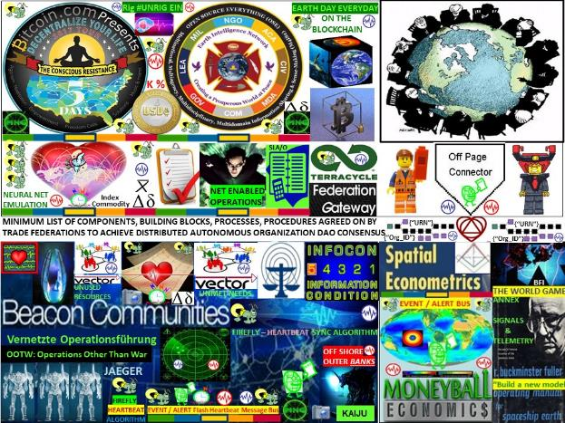

FIGURE 22: **MEDIATION GATEWAY:** Federations sustainable economics / Off Pagers [LINK](http://www.sawconcepts.com/index/id89.html)

**MEDIATION GATEWAYS are needed among entities, organizations, trade federations adhering to rules, laws, consensus metrics, meters and non-conforming** **entities, organizations, corporations**

Building a “new” internet will involve building 2 nets: one net is being built that tends to be centralized and is a private mesh among large government and / or large corporations featuring controlled access permission for example, Ripple that becomes more decentralized the more hubs installed.

The second net is a more decentralized, shared internet, internet of money based on the concept of Distributed Autonomous Organization DAO infrastructure keeping in mind that the DAO term was coined by a military funded think tank — the RAND corporation circa 2001.

Mediation gateways between centralized and decentralized blockchain implementations are needed to match transaction speeds between the centralized architectures that tend to be faster than the decentralized architectures. Work flow logic, business rules, metrics, meters will differ among the centralized, decentralized systems as well as among the myriad blockchain memes in general.

REFERENCE ARTICLE: #ConsenSys How to Build a New Internet

[LINK](https://media.consensys.net/lets-build-a-new-internet-4d897def3f66) https://media.consensys.net/lets-build-a-new-internet-4d897def3f

Simple Always* Wins Concepts caveat: * when standing on the shoulders of giants

A close up of a device

Description generated with high confidence